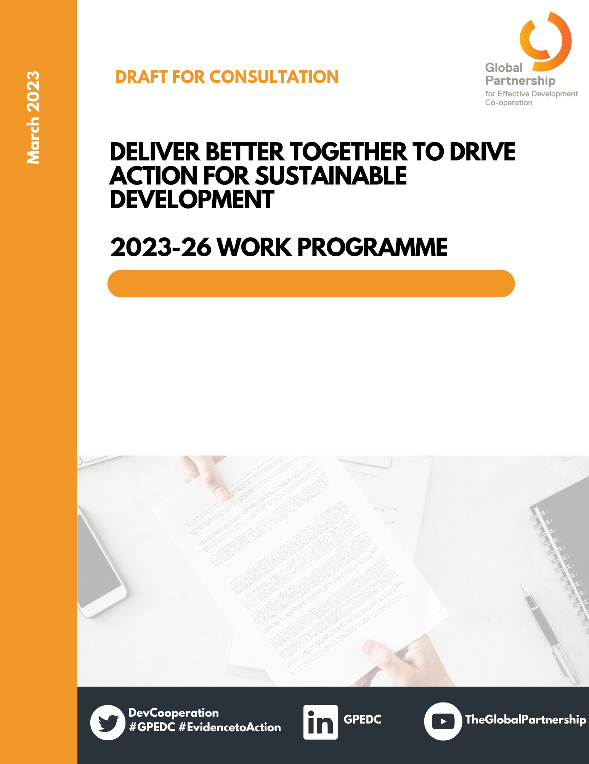

PART I: STRATEGIC VISION AND OBJECTIVES
1. What is the Global Partnership and why is it important?
The Global Partnership for Effective Development Co-operation (GPEDC) is the primary multi-stakeholder platform for driving the effectiveness of all types of development co-operation to deliver sustainable development. It significantly changed the global architecture of development co-operation more than ten years ago when it was launched to sustain political momentum and improve policies and partnerships by promoting four shared effectiveness principles: country ownership, focus on results, inclusive partnerships and transparency and mutual accountability. The Global Partnership provides evidence that enables tracking progress and taking action on these principles and related commitments.
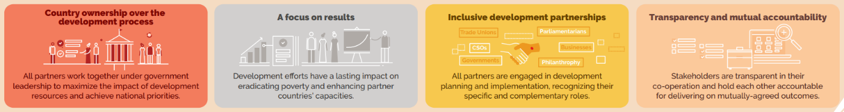

2. Why is the effectiveness of development co-operation more important than ever?
Development co-operation is undergoing important changes and has to respond to new and complex realities, often in challenging contexts:
Multiple, overlapping challenges, including poverty and inequality, conflict and fragility, the COVID-19 pandemic and climate change are undermining progress across the 2030 Agenda for Sustainable Development and driving up countries’ financing needs.
Official development finance providers, implementing entities and partnerships have proliferated leading to a more fragmented and complex global development co-operation landscape, straining partner countries’ capacities.

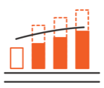
Development actors made only limited progress towards their commitments on effective development co-operation, which erodes mutual accountability and trust. This undermines the open dialogue that would allow the forging of more effective partnerships in a constantly evolving development landscape.
These challenges are deeply interlinked, context-specific and have profound effects at global and country level. Because of their complexity, and despite a growing urgency, political momentum to address them is hard to maintain.
Development actors keep facing tough choices when adapting their policies, strategies and partnerships to respond to ever new realities and crises. Some of the tensions and dilemmas include adapting to and minimising fragmentation, prioritising the needs of the most vulnerable while tackling global challenges such as climate change, balancing support to public sectors while promoting whole-of-society approaches, and finding the right balance between short-term results and long-term capacity building.
Political leadership around a shared agenda of more effective development action at country and global level is more critical than ever. It is key to strengthen trust in this time of uncertainty and to inform dialogue and decisions on how to get back on track with the Sustainable Development Goals (SDGs).
Improving the effectiveness of development co-operation can take diverse forms:
- Supporting evidence-based multi-stakeholder dialogue on what is working and what is not so partners can align and drive greater accountability on shared priorities and actions
- Continuously adapting to changing needs and conditions and responding in strategic ways that harness partners’ comparative strengths and build capacity for stakeholders
- Demonstrating the impact of co-operation in delivering on the SDGs through promotion of more systematic learning to foster innovation and scale up tested, locally-led solutions for greater development impact.

3. What is the Global Partnership offering?
The Geneva Summit Declaration reaffirms that effective development co-operation is critical in addressing crises, supporting sustainable recovery and putting the world on track to deliver on the 2030 Agenda for Sustainable Development. The 2023-26 work programme builds on this commitment, and the support and energy demonstrated at the highest political level in Geneva.
Effective development co-operation which is country-led, results-oriented, transparent, and accountable is essential to build trust for inclusive partnerships and improved development outcomes. Governments, development partners, civil society and others must translate their commitments to action and tailor development solutions to the challenges faced in different and new contexts. Better policies, practices and partnerships are a key driver to deliver the 2030 Agenda for Sustainable Development.

4. How will the Global Partnership operate?
The GPEDC Steering Committee drives the work programme implementation by all its constituencies. Each Co-Chair and Steering Committee member will mobilise their constituencies and peers, relevant bodies and partners in support of driving all core outcomes and activities of the work programme. A priority is to strengthen voices of partner country governments and supporting them in leading the new monitoring and related inclusive dialogues and identification of follow-up action at the country level. The OECD-UNDP Joint Support Team supports the monitoring, secretariat and advisory functions, advocacy and communication, subject to adequate resources.
PART II. CORE OUTPUTS AND ACTIVITIES FOR 2023-26
The 2023-26 GPEDC Work Programme is centred on three core outputs and related activities to strengthen the effectiveness of development co-operation to achieve progress towards the SDGs:
- Generating EVIDENCE, through the new monitoring
- Driving INFORMED POLICY DIALOGUE & ACTION, through country dialogues and strategic partnerships
- Fostering POLITICAL AWARENESS & UPTAKE, through targeted advocacy and outreach
Alongside these core outputs and activities members lead thematic learning initiatives on a limited set of shared priorities to enhance development outcomes and results. The core outputs and activities are also supported by advocacy and outreach in the context of a series of select global events.

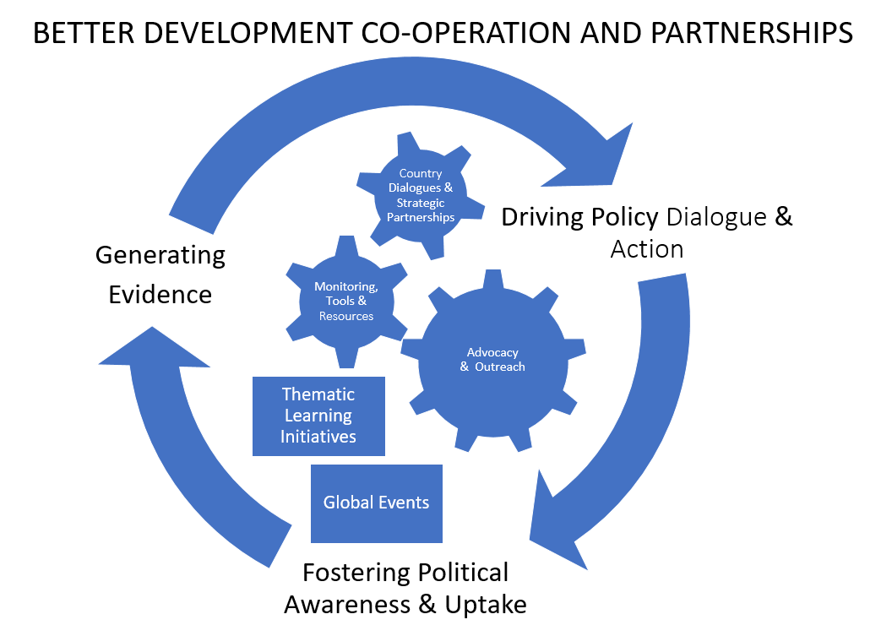

1. Generating EVIDENCE: The New Monitoring
OUTPUT: Stronger evidence on the uptake of the effectiveness principles at the country level and a better understanding of context-specific political and operational challenges that delay progress.
This focuses on key learnings from the GPEDC monitoring on how to improve the design and quality of development co-operation interventions to address bottlenecks and help deliver better development results. It also includes greater use of other existing GPEDC knowledge resources and tools by stakeholders in countries that generate learning for improving the effectiveness of different types of partnerships or thematic priorities.
Implementation of the new monitoring exercise – launched at the Geneva Summit – will be the primary avenue for the Global Partnership to address the challenges of effective partnering and demonstrate its value and achievements at the country level. The exercise will continue to monitor progress on past commitments, including on the unfinished business of the aid effectiveness agenda, and will generate evidence on stakeholders’ efforts to adhere to the four effectiveness principles.
With its four-year global rolling round, the exercise enables countries to make linkages with and strengthen existing country-level processes. It includes an inclusive and strategically-oriented inception phase in countries to ensure multi-stakeholder engagement under government leadership. Data collection is streamlined with a new online data reporting tool, and through use of a new global dashboard providing an overview of progress on the application of the principles. The exercise will continue to provide official data for global SDG review processes.
Support to country-led implementation of the monitoring exercise has the ambition to:
- Help generate common understanding and broad-based ownership of development challenges and priorities in participating partner countries through locally-led, inclusive and participatory dialogues;
- Identify key action points, through inclusive and country-led processes, on how to improve the design and quality of partnerships in participating partner countries;
- Ensure a more complete monitoring cycle – of engagement, results, and action – so the 4th monitoring round leads seamlessly into participation in forthcoming global rounds.

2. Driving INFORMED POLICY DIALOGUE & ACTION: Country Dialogues & Strategic Partnerships
OUTPUT: Intensified national and global multi-stakeholder policy dialogue and action on effectiveness challenges at country level with all relevant stakeholders engaged, contributing to more informed policy decisions. The monitoring results will be the driver for such dialogue. It aims to generate insights and broad-based ownership and common understanding of how to address obstacles and harness opportunities for better development outcomes in countries. This requires the active engagement of all relevant stakeholders. An ambition is to link country-level results and action with relevant regional and global policy dialogue to scale up best practices and inform SDG follow-up, with the priority placed on in-country action.
Data from the monitoring exercise enables multi-stakeholder engagement on effectiveness at the country level, global accountability, and should lead to behaviour change. The new monitoring process has an inclusive country-level dialogue to discuss findings among partners to improve effective development co-operation and to build in-country capacity. It aims to inform policy debate and change in countries where the monitoring is taking place, as an integral part of the monitoring exercise, and in line with existing national dialogue processes.
This requires intense preparation with the right actors in countries, regionally and globally. Strategic partnerships will help to adequately support multi-stakeholder and in-country action around the monitoring and foster political momentum, peer learning and dialogue at regional and global level.
Support to country dialogues and strategic partnerships has the ambition to:
- Mobilise relevant policy communities to broaden the ‘effectiveness ecosystem’
- Enable country governments to drive monitoring, dialogue and knowledge sharing
- Foster learning and influence policy and behaviour change at country level
- Deepen strategic partnerships at all levels based on priority needs (see bi-annual action plan).
3. Fostering POLITICAL AWARENESS & UPTAKE: Targeted Advocacy and Outreach
OUTPUT: Raised political awareness of the benefits and uptake of effective development co-operation and systematic learning.
This includes good practices of how to apply the effectiveness principles across partnerships and delivery models available to all actors through the GPEDC website and increased policy focus on effectiveness in relevant national settings and regional and global fora.
The Global Partnership’s advocacy work is centred around demonstrating the why, how, what of the effectiveness agenda to enhance the impact of co-operation in delivering on the SDGs. With this being a collective learning agenda, the advocacy work focuses on translating political commitments to action, notably advocating for the monitoring exercise to enable evidence-based dialogue, action and accountability on effectiveness commitments at all levels.
In support of dialogue and action at the country level and under leadership of the Steering Committee:
- A communications and advocacy plan will enable relevant stakeholders across the Global Partnership’s constituencies – including new as well as inactive partners – to lead targeted communication and knowledge-sharing efforts, raise awareness of and foster peer-learning, mobilize political buy-in for and promote the uptake of the findings of the monitoring exercise across countries and contexts, including global, regional, local and thematic settings.
- Various communication and advocacy activities are planned, including publishing Stories of Progress, articles, blogs, newsletters as well as updating a country dashboard, the official website, and the Knowledge Sharing Platform (KSP).
- High-level strategic engagements will be made throughout the year in key global and regional fora as well as working with a communications group to deliver and reinforce key messages that resonate with external audiences.
Support for political awareness & uptake has the ambition to:
- Mobilize political buy-in for and promote uptake of monitoring findings across countries and contexts, as well as with new and inactive partners
- Promote the benefits of more effective development co-operation through communications and advocacy activities
- Engage ‘champions of effectiveness’ through select global and regional fora and through an informal communications group so the Global Partnership can collectively deliver and reinforce effectiveness

4. MEMBER-LED THEMATIC LEARNING INITIATIVES
Steering Committee members will support ‘thematic learning initiatives’ to share insights and good practices and drive country-level action to foster policy change. They will incubate, test and share experiences on how to apply the effectiveness principles to relevant challenges and link up with different communities and thematic networks to shape the broader ‘effectiveness ecosystem’, i.e. the community of those promoting greater effectiveness of development co-operation as part of the broader policy and operational environment.
‘Thematic learning initiatives’ are informed by commitments of the Geneva Declaration, self-governed and -funded, and may, on a case-by-case basis, benefit from minimal JST support only. They can be annual or longer-term, depending on partners’ ambitions and support before they can get ‘a life of their own’ or dissolve again. Priorities of ‘thematic learning initiatives’ will be decided by and reported back to the Steering Committee and can include the uptake of existing thematic knowledge resources of the Global Partnership (see Annex 4 of the Geneva Declaration) to promote learning, knowledge sharing and policy action. They centre around development of guidance and tools, promoting dialogue, and/or piloting and collecting good practice to bring them to action at country level. Direct engagement of or feedback loops with countries will be critical to ensure relevance, and they should be led by at least two co-leads. Substantively they can include, but also go beyond issues covered in the monitoring.
The initiatives are a more horizontal way to follow through on some of the Action Areas that have been pursued during the 2020- 2022 Global Partnership Work Programme and provide opportunities for stakeholders to have their own learning spaces (e.g. within a constituency). Members are encouraged to also involve academic researchers to strengthen the policy-science interface.
Over 30 Global Partnership Initiatives (GPIs) have contributed to the Global Partnership over the course of its history. The new thematic learning initiatives will not revive previous GPIs, with the exception of the Global Partnership Initiative on Triangular Co-operation, which will continue its work in its current, independent set-up and include the work started under the Action Area on Triangular Co-operation of the 2021-22 GPEDC Work Programme to ensure uptake of the voluntary guidelines on effective triangular co-operation.

PART III. INDICATIVE ACTION PLAN FOR 2023-24
The 2023-26 work programme is accompanied by biennial action plans. The below is an indicative plan of proposed activities for 2023 and 2024. It includes timing, lead and support, and Joint Support Team roles. It will be updated over the four-year period of the work programme. Mid-way through the 2023-2026 work programme, stakeholders will take stock of the available findings from the monitoring and other evidence to inform global action and fine-tune work for 2025/26.
Objective | Activity/Output | Timing | Lead and Support | Joint Support Team
OUTPUT 1: Generating EVIDENCE: The New Monitoring
1. Ensuring a successful Launch/ Pre-inception | Formal outreach from Co-Chairs to political leadership of Partner Country Governments to kick-off the monitoring exercise at country-level | Continuous | Co-Chairs | UNDP
 | Partner Country Governments confirm their commitment to conduct the exercise for the Global Rolling Round and initiate Institutional preparations, including the identification of the national coordinator | Continuous | Partner countries | UNDP
 | Communications and advocacy products for the monitoring | Q1 2023 & continuous | Co-Chairs | UNDP
 | Mobilisation of constituency representatives in each country | Q1 2023 & continuous | SC members
2. Delivering inclusive and strategic country-level inception phase | Monitoring guide published in English, French and Spanish | Q1 2023 | OECD | OECD
 | Virtual briefing sessions organised for national coordinators | Continuous | UNDP (lead), OECD (method. /reporting) | OECD/UNDP
 | Country-specific monitoring roadmaps developed for each country | Continuous | Partner countries | UNDP
 | Inclusive and strategic inception kick-off meetings organised in each country | Continuous | Partner countries
 | Engagement of constituency representatives in country-level inception activities/kick-off meeting | Continuous | SC members
3. Ensuring rigorous Data Collection; producing actionable Reporting Products | New online data reporting tool developed and launched | Q2 2023 | OECD | OECD
 | Reporting from across relevant national government entities; coordinating data reporting and validation from relevant country-level stakeholders | Continuous | Partner countries | OECD
 | Providing requested data to national coordinator | Continuous | Constituency focal points at country level
 | [Individual] Country results briefs developed and published | Continuous, after countries submit final data | JST, based on (OECD-led) results calculations | OECD
 | Annual results summary (with collated results for countries which submitted final data within 2023) | Q1 2024 | JST, based on (OECD-led) results calculations | OECD
 | Data reporting to global SDG review process (with data for countries which submitted final data within 2023) | Q1 2024 | OECD | OECD
OUTPUT 2: Driving INFORMED POLICY DIALOGUE & ACTION:
Country Dialogues & Strategic Partnerships
1. Ensuring Dialogue, Learning and Follow-up in Countries | Inclusive and strategic-level country-level action dialogues organised; action plans prepared | Continuous | Partner countries | UNDP
 | Engagement of [strategic-level] constituency representatives in country-level action dialogues; contribution to action plans | Continuous | SC members
 | Implementation of country-level action plans | Continuous | Partner countries
2. Strengthening Global Governance & Decision-Making | Mapping of Steering Committee members and their constituencies | Q1 2023, to be updated | Co-Chairs | OECD
 | Confirm/renew membership based on proposals for rotation (cf. TORs) | Continuous | Co-Chairs | OECD
 | Regular dialogue with individual Steering Committee members (induction session to new members upon demand) | Continuous | Co-Chairs | OECD/UNDP
 | Non-executive SC members’ priorities for 2023 | Q1/2 2023 | 4th Co-Chair and NE SC members | OECD
 | Introducing the Knowledge Sharing Platform space for Steering Committee Members | Q1/2 | Co-Chairs | UNDP
 | 25th SC Meeting (virtual) | 30-31 May | Co-Chairs | OECD/UNDP
 | 26th SC Meeting (virtual or in-person tbc) | (tbc) | Co-Chairs | OECD/UNDP
3. Deepening existing or establishing new Strategic Partnerships | Agree on UN Development System country level support to monitoring | Continuous 2023-2024 | SC members (incl. at country level) | UNDP
 | Africa Caucus to identify priorities, discuss engagement and leadership questions, through regular technical meetings (incl. ahead of Steering Committee Meetings) | Continuous, set up in Q1 2023 | AUDA-NEPAD and DR Congo | OECD and UNDP
 | DAC Effectiveness Community at HQ and country level to engage in GPEDC work programme and promote peer learning | Continuous | Sweden, DAC champions | OECD
 | MDB Working Group on development effectiveness to inform dialogue and action | By Q3 2023 | Sweden and IADB | OECD and UNDP
 | Dual country engagement (e.g. ASEAN, G20, UNOSSC, Delhi Process, UNDESA etc.) | Continuous 2023-2024 | Indonesia | OECD and UNDP
 | Global private sector networks and/or group of friends of the Kampala Principles | By Q3 2023 | Co-chairs, Private Sector SC member, BLC | OECD and UNDP
 | Academia, Researchers and Think Tanks including on effective South-South Co-operation to strengthen the policy science interface on effective development co-operation. | Continuous 2024 | Co-Chairs, SC members | OECD
 | Asia-Pacific Caucus | 2024 | Indonesia, Nepal, Philippines, PIFS | UNDP
 | Latin American and Caribbean Caucus | 2024 | Colombia, El Salvador | UNDP
4. Resourcing the GPEDC and its Secretariat | Outreach to SC members and constituencies to mobilize the required resources for the JST to deliver on its mandate. | As needed, continuous | Co-Chairs | OECD and UNDP
OUTPUT 3: Fostering POLITICAL AWARENESS & UPTAKE: Targeted Advocacy and Outreach
1. Developing a Communications and Advocacy Plan | Developing a communications and advocacy plan for 2023 and 2024 (refer to section IV below on opportunities for global advocacy) | Q1 2023 | JST, Co-Chairs | UNDP
 | Developing and disseminating assets on the GPEDC Trello Board, website, and the Knowledge-Sharing Platform including re-doing the website to promote new assets | Continuous | JST | UNDP
 | Establishing and maintaining a Communications Group of external communication experts | Continuous | JST and external communication experts | UNDP
2. Awareness raising on the effectiveness agenda | Publishing key country stories of progress and thought pieces to build momentum around effectiveness at country level | Continuous | JST | UNDP
 | Developing and promoting narratives for constituencies: Tailor-made narratives drawing connections between the GPEDC ‘offer’ (including, but not limited to the monitoring exercise) and constituencies’ strategic objectives and key political guiding posts. | Continuous, demand-driven | JST | UNDP
 | Updating development partner and partner country dashboard based on latest monitoring progress, engaging partners to use the Knowledge-Sharing Platform | Continuous | JST | OECD and UNDP
3. Mobilization of political buy-in for the monitoring exercise | Engagement at strategic events through development and promotion of key messages, support to the organization of side events and/or informal (bilateral) meetings | Continuous, demand-driven | JST | UNDP
4. Promoting the uptake of the findings of the monitoring exercise | Horizon scanning for peer learning: Best practices to address opportunities identified in each country during the monitoring exercise. | Q1/2 2023, with quarterly updates afterwards | JST | OECD and UNDP
 | Promoting findings from the monitoring exercise at strategic events | Q4 2023/Q1 2024 onwards | JST | UNDP

Member-led Thematic Learning Initiatives (INDICATIVE – TO BE CONFIRMED BY POTENTIAL LEADS AND MEMBERS)
1. Data | Uptake of Bern Call to Action to guide effective support to national statistical systems and the use of data for development. | 2023-24 | Switzerland | -*
2. Private Sector engagement | Uptake of Kampala Principles Assessment & Toolkit to scale up private sector engagement at country level in a series of pilot or champion countries and phase-out BLC and PS Working Group. | 2023 (to be revisited at the end of the year) | Indonesia, private sector | -*
3. Effective Delivery of Climate Action | Fostering inclusive dialogue with partner countries on their priorities for more effective climate action and how the effectiveness principles support those. | 2023-24 | AUDA-NEPAD, Sweden, non-executives | -*
4. South-South Co-operation | Finalizing methodology and roll-out of the South-South Co-operation assessment | 2023-24 | Colombia, Indonesia, Switzerland | -*
5. Civil Society | Enabling Civil Society Participation and addressing shrinking civic space. |  | Sweden, CPDE, WINGS | -*
6. DAC Effectiveness | Sounding Board on Effectiveness to drive behaviour change and peer learning among DAC members. | Continuous | Sweden, providers represented in the DAC | OECD
7. African Effectiveness Priorities | Africa Caucus (at least two meetings ahead of Steering Committee meetings). | Continuous | AUDA-NEPAD | UNDP

Opportunities for Global Advocacy in 2023 and 2024
A calendar of events for 2023 and 2024 will conclude the action plan for the year. Events will be carefully selected based on their contribution to priority actions on advocacy, outreach, learning and strategic partnerships. A preliminary list of key events includes the following but is not limited to these events.

EVENT | DATE |  |  | TYPE OF EVENT
2023
UN 5th Conference on Least Developed Countries |  | 5 - 9 March | UN
Development Co-operation Forum |  | 14 – 15 March | UN
UN Financing for Development Forum |  | 24 - 27 April | UN
KOICA Learning and Acceleration Programme |  | May/June | Regional
25th Meeting of Steering Committee |  | 30 – 31 May | Internal
UN High-Level Political Forum |  | 10 – 19 July | UN
SDG Summit |  | 19 – 20 September | UN
26th Meeting of Steering Committee |  | TBD | Internal
Indonesia Summit on Multi-Stakeholder Partnerships |  | TBD | Regional
Busan Partnership Forum |  | TBD | Regional
2024
Summit of the Future |  | 22-23 September | UN
4th International Conference of the SIDS |  | 2024 | Regional
UN World Data Forum |  | 24 November | UN
Additional events could include: OECD DAC Senior or High-Level Meeting, AU Meetings, SIDS Summit, G20 Summit
Other regional events that Steering Committee members are engaged with throughout the year will also be highlighted as key opportunities.

Annex 1: Budget
An indicative bi-annual budget will be developed to accompany the Action Plans, indicating the resource needs of the Joint Support Team for the different strands of the core activities, complemented by an indicative budget for member-led activities such as thematic initiatives and learning spaces, as well as GPEDC-member financed ad-hoc contributions for High Level Meetings and other activities that directly contribute to the core activities of the GPEDC work programme.

See Annex 3 Geneva Summit outcome document and TORs
Accountability for progress on past commitments is a valid political ambition, and action in this connection is linked to the GPEDC monitoring exercise given that it generates evidence on commitments. The term ‘’unfinished business’’ does not have an agreed definition or scope but many stakeholders understand it to refer to commitments made prior to Busan (2011).
The Global Partnership monitoring exercise provides official data for SDG indicators 5.c.1, 17.15.1, and 17.16.1.
Depending on country context, the challenges can include those for which the monitoring will provide evidence of state-of-play/progress, such as related to civic space, LNOB-related priorities, effectiveness of different modalities of co-operation such as private sector engagement, and long-standing effectiveness issues such as related to predictability, results frameworks and data/statistical systems, and untying aid. Building on the monitoring findings, country action dialogues may also draw in additional evidence such as on effectiveness of financing for sustainable development (INFFs), effectiveness of climate finance and action, recovery and preparedness for pandemics, disaster recovery and preparedness, multilateral effectiveness and effectiveness of locally-led development.
This would require additional resources to the JST that could be mobilized once the full funding envelope for the core activities supported by the JST has been secured.
For clarity and simplicity, to the extent feasible only one of OECD or UNDP is listed, per the lead organisation in the JST Division of Labour. However, it should be understood that the non-listed organisation will, as relevant and feasible, contribute and provide inputs to activities and outputs.
Timing for all monitoring tasks is as per the new monitoring guidelines. Current status can be followed through the GPEDC monitoring dashboard.
For clarity and simplicity, to the extent feasible only one of OECD or UNDP is listed, per the lead organisation in the JST Division of Labour. However, it should be understood that the non-listed organisation will, as relevant and feasible, contribute and provide inputs to activities and outputs.
Fully led by Steering Committee members, with possible and light support by the JST depending on funding additional to the full resourcing of the JST core budget (see OECD/UNDP division of labour). The status of each initiative will be reviewed and discussed by those leading them and in the Steering Committee annually in a light and pragmatic way.

